UML Design Modeling

Ethan Meier
CST499 Capstone for Computer Software Technology
Charmelia Butler
October 27th, 2025

Introduction
The Online Course Registration System allows students to register, drop, and manage courses through a web-based platform. It gives students the ability to view schedules, check availability, and make updates to their enrollments without needing manual help from administrators. This paper translates the requirements identified in week 1 Software Requirements Specification (SRS) into a system design using Unified Modeling Language (UML) diagrams. These models show both how the system is structured and how it behaves when users interact with it.
The UML diagrams in this paper include a Use Case Diagram, Class Diagram, Sequence Diagram, Activity Diagram, and State Diagram. Each diagram helps visualize different parts of the system to support development and communication among team members. This paper also explains the four main levels of software testing: component, integration, system, and acceptance testing. These tests help confirm that the application performs as expected and meets all the user requirements.
Thesis Statement: This paper presents UML models for the Online Course Registration System and outlines testing approaches to confirm functionality, usability, and quality.
Section 1: UML Design Models
Figure 1. Use Case Diagram for Online Course Registration System
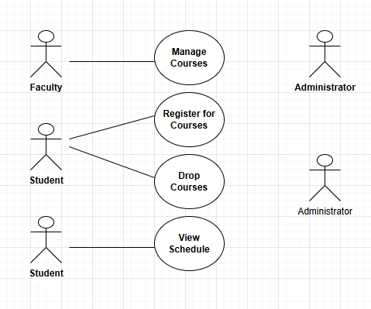
This diagram shows how different users, such as students, faculty, and administrators, interact with the system. Students can register for courses, drop courses, view their schedules, and manage enrollments. Administrators can add, remove, or modify course information.
Figure 2. Class Diagram for System Components
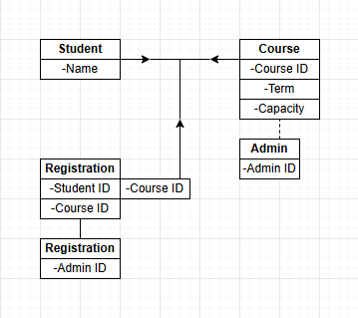

The class diagram shows the main components of the system and how they relate to each other. The main classes include Student, Course, Registration, and Admin. Each Student has a unique ID and can be linked to multiple courses. Each Course includes a course ID, term, capacity, and enrolled list. Registration connects students to their chosen courses, while Admin manages course data and system updates.
Figure 3. Sequence Diagram for Registration Process
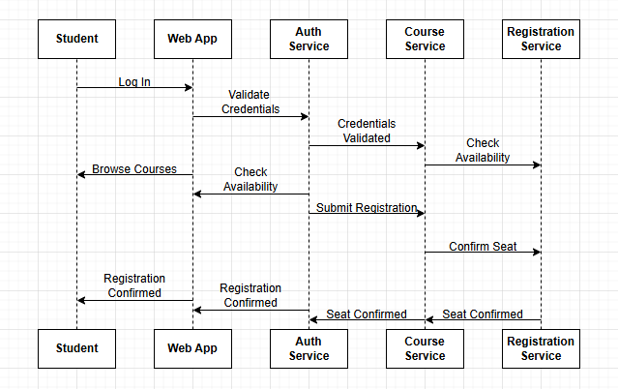
This diagram shows the steps a student follows to register for a course. The process begins when the student logs in, browses available courses, checks if a course is open, and submits the registration. The system confirms the seat and sends a registration confirmation message back to the student.
Figure 4. Activity Diagram for Course Enrollment Workflow
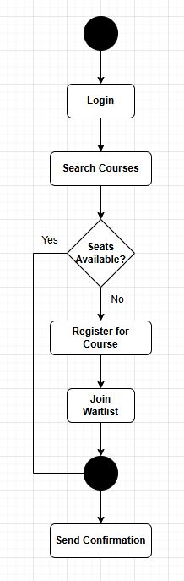
This activity diagram outlines the main steps in the registration process. The student logs in, searches for courses, selects a course, checks availability, and either registers or joins the waitlist. Once completed, the system provides confirmation.
Figure 5. State Diagram for Course Availability
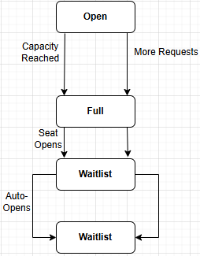
This Diagram shows how a course changes, depending on availability. A course starts as Open, becomes Full when capacity is reached, and moves to Waitlist if additional students attempt to register. If a student drops the class, a seat opens, returning the state to Open.
Section 2: Testing Levels
Software testing is used to verify that each part of the system performs correctly and that all features work together as planned.
Component Testing
Component testing focuses on individual parts of the system such as the login screen, registration form, and course search feature. Each module is tested separately to ensure it works correctly before it connects to other components.
Integration Testing
Integration testing checks how different modules interact with each other. For example, it ensures the login system correctly connects to the registration system and that course details display properly once a student signs in. It helps detect communication or data flow errors between parts of the system.
System Testing
System testing involves testing the whole system as one complete application. This step ensures that all parts, such as login, registration, course management, and scheduling, work together smoothly in a realistic environment.
Acceptance Testing
Acceptance testing is the final phase before the system is released. Real users such as students and staff test the system to make sure it meets their needs and works as described in the SRS. Any missing feature or usability problems are reported and fixed before launch.
Conclusion
The UML diagrams provide a clear view of the Online Course Registration System’s structure and behavior. These models help developers and stakeholders understand how users interact with the system and how information flows between different parts. The four levels of testing, which are component, integration, system, and acceptance testing, help make sure that the software works correctly and meets expectations. Together, the use of UML design and structured testing helps build a reliable, efficient, and user-friendly registration system.

References
Mathues, S. (2023). One step at a time: A roadmap for problem solving & making a difference. The University of Arizona Global Campus.
Sommerville, I. (2016). Software engineering (10th ed.). Pearson Education.
Tsui, F., Karam, O., & Bernal, B. (2018). Essentials of software engineering (5th ed.). Jones & Bartlett Learning.

